Route Planning Simulation
Report
Lan Wu
Main Content: Simulation of First-order route planning, Quadratic Optimization, and Convex Optimization.

INTRODUCTION
In past few decades, the advancement of automatic technology has revolutionized both civilian and military domains, which brings unmanned vehicles to a historically new status. Particularly, the unmanned ground vehicles (UGV) equipped with Global Positioning System (GPS), Light Detection and Ranging (Lidar), and high-definition (HD) stereo cameras have received extensive scientific attention. Compared to UGV’s former version on the ground of landmark detection and recognition techniques, the latest UGV owns optimal performance in path planning as well as sophisticated obstacle avoidance. What’s more, powerful path tracking technique has also been applied thanks to recent technological breakthroughs in GPS, image processing and Lidar technologies. Therefore, autonomous maneuvers can be fulfilled in most austere outdoor environments with the cutting-edge UGV.
However, the existing limitation of GPS in real environments together with the occlusion caused by ground-level obstructions greatly impact the function of Lidar and HD cameras. Undoubtedly, it imposes us with new challenges. Therefore, the idea is that, if we equip each automatic car with an unmanned aerial vehicle, then by the real-time image processing function we can promote the precision of both railway recognition and route planning. So in this report, I will introduce the prototype system as well as the simulation outcome.
As shown in Figure 1, the miniaturized UAV-assisted UGV testbed is the prototype of the simulation system. The testbed is composed of one UAV flying at the height of about 3 meters, one UGV running on the floor in an area of about 6x6 meters and a few beacon lights. For testing purposes, the testbed will only activate one beacon light at random each time. Only after the UGV passes through the activated beacon light, will the testbed turn on the next beacon light randomly. The test is designed to investigate how effective UAV can guide UGV towards its targets. And in each simulation, the value of starting point, car direction, and destination will be randomly assigned.
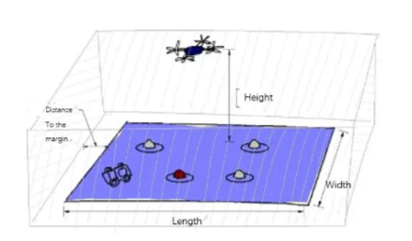
Figure 1. Illustration of the Miniaturized UAV-assisted UGV Testbed

Method

First Order Route-planning Algorithm
Circular Arc Method
The circular arc method is to generate a circular arc as the route by three parameters: the car vector (V₀), the car-point (C₀) and the target point (T₀). All of them are 2*1vectors. The car vector indicates the direction of the car, which can be derived from the (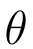) by the formula:
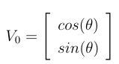
The car-point (C₀) is directly from the camera. The target point is the point at which the infrared light is offset by a certain distance (d), which can be generated by the formula (let L be the coordinate of the light):
Let 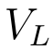 be the vector from C to L
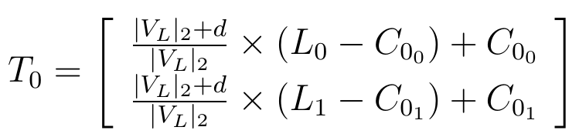
Then the circular arc can be derived by:
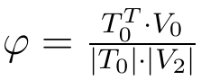
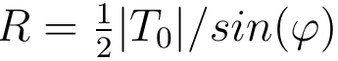
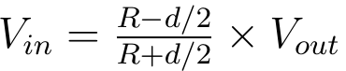
(d is the distance between two wheels)
where we finally get the relationship between the speed of inside wheel and the speed of outside wheel.

Approximation Method
In Figure 2, the approximation method is to gradually approach the target point by rotating a certain proportion of the angle between the car-point (C₀) and the target-point (T₀) each time.
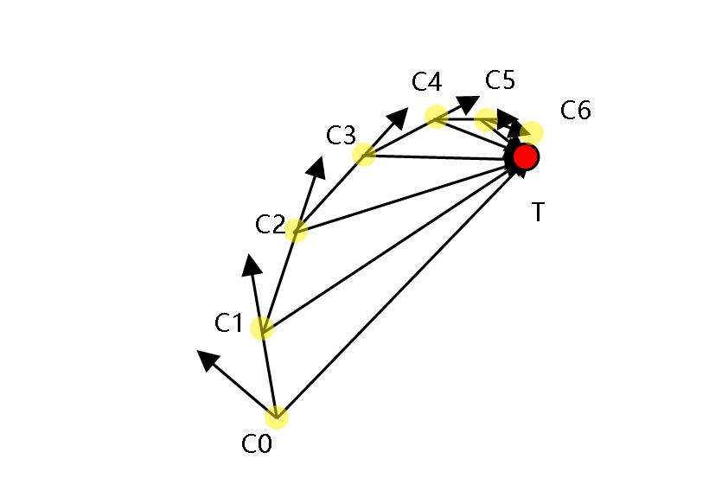
Figure 2. Approximation Method Illustration
This method does not produce a clear path, but adjust the direction of the car by capturing the position usign the camera in real time. Since the car is a differential steering system, the car direction can be adjusted by controling the speed of two motors, let they be Vin (inside speed,the smaller one) and Vout (outside speed, the bigger one). According to a paper about the differential steering system written by G.W.Lucas, there is a formula, let V_{t} be the direction from C₀ to T₀ :
Let 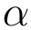 be the angle beteen T₀ and V₀.
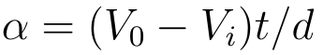
Then we use the multiplication cross to assign Vin and Vout to Vr and Vl. If the T₀ is on the right side, Vl = Vo and Vr = Vi, otherwise Vl=Vi and Vr=Vo.

Second Order Route-planning Algorithm
In mathematics aspect, with the starting point, direction of car, and the terminal point, we can find the only quadratic curve satisfies these requirements if we know the direction of the quadratic curve. Here we have two steps. First we need to calculate the curve function once we decide the direction of the quadratic curve. Secondly, we need to decide which curve to use since there are infinite directions.

Rotation
In order to get the quadratic curve function according to the direction of it, we need to rotate the starting point 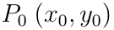, direction of car 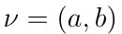, and the terminal point 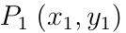 with respect to the origin at the beginning. Suppose that the rotation angle is (counterclockwise):
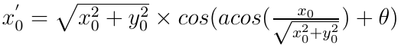
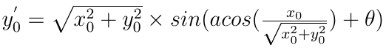
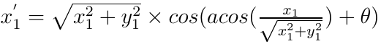
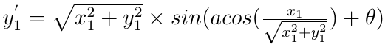
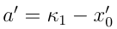

Curve Calculation
We set the standard quadratic function form to be :
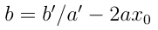
To get the actual point of the planned route, we just need to rotate points back, which is very similar to what we do in rotation.

Optimization Method
To get the optimized quadratic route, we need to set a reasonable criterion. The first method is to choose the route with the shortest distance.
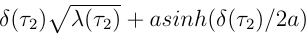

CVX Route-planning Algorithm
CVX is an outstanding tool for constructing and solving convex optimization problems. According to the guide page of CVX, it supports three different types of disciplined convex programs (DCP):
- Maximization problem, consisting of a convex objective function and zero or more constraints.
- Minimization problem, consisting of a convex objective function and zero or more constraints.
- Feasibility problem, consisting of one or more constraints and no objective.
Therefore, it is feasible to apply CVX route optimization in UAV-assisted UGV system. Here we formula the following DCP to minimize the total change of car direction:
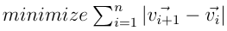
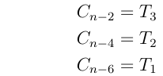
V is the n dimension vector to store changing direction of car among time. V₀ is the original car direction. C is the n dimension vector to store the changing car coordinates. C₀ is the original car point. T_{1,} T₂, T₃ are the points offset a certain distance from the T₀. The objective of using these three points not the T₀ is to steer clear of infrared lights rather than crashing it. Figure 6 shows a result of CVX route planning:
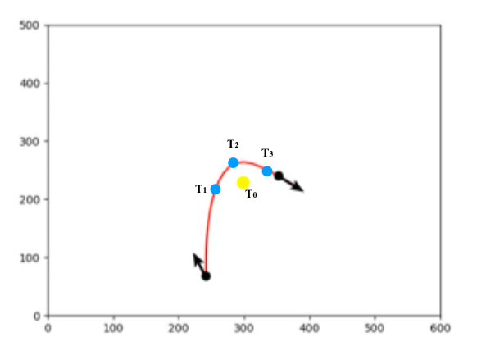
Figure 10. Result of CVX Optimization

Simulation Outcome

First Order Simulation
The first-order simulation provides us with circular paths that require the least action of the automatic car. In these situations, the velocity difference between the wheel inside and wheel outside remains constant so that a perfect circle is created. Pictures following are the simulations outcome, where the blue point represents random start point and one of five purple points is the target bacon.
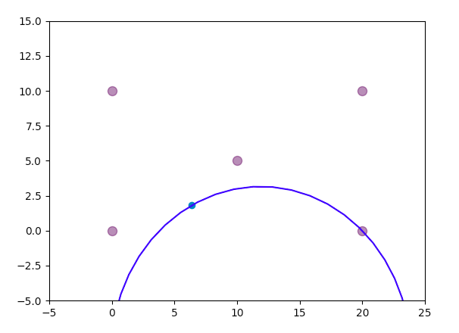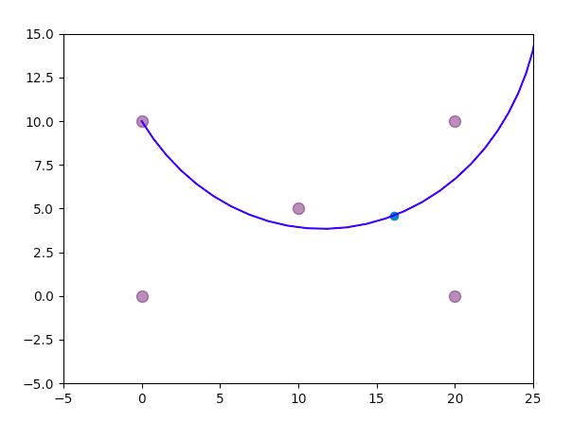

Quadratic Simulation
In Mathematics perspective, quadratic route appears to be much smoother due to the changing curvature compared to the first-order route planning. And under various scenarios, we can set different restricted conditions. Pictures in the following are outcome of the shortest path restriction in quadratic planning:
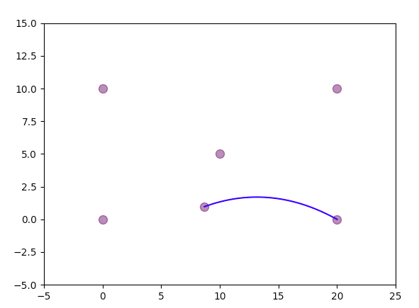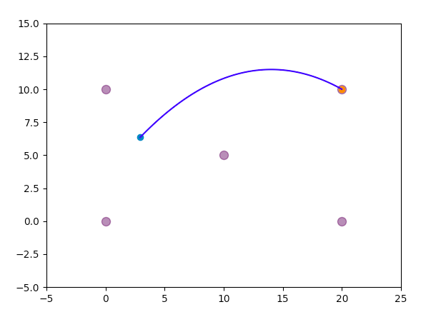
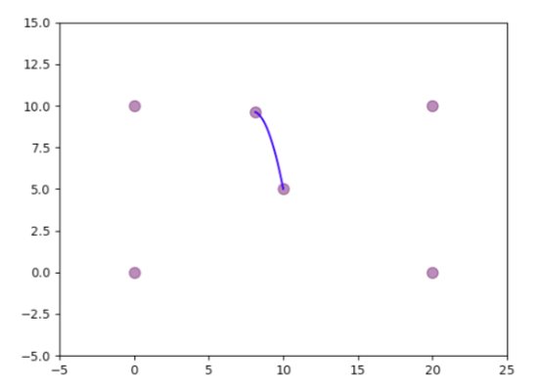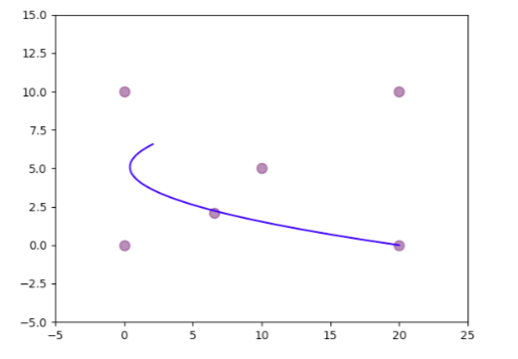

Convex Simulation

